**ENME 493 Machine Component Design**

**Project Report**

Comparison Between Inverted and Standard (Upright) Forks

By: Preetkamal Grewal, Navdeep Saggu, Frazer Paetz, Abhay Chhabra, Raya Subah, Fatima Nasir, Shehzaad Brar

Submitted on 2022-04-12

**1. Executive Summary**

The machine project goal is to model and analyze an inverted motorcycle fork, and compare it to the standard upright fork. Comparison of these two designs is done through analysis on the fork spring as it is the most significant component in the design. Specifically, the stresses and life cycles of the inverted and the standard fork springs were determined. From here, cost analysis is also completed on each design. Additionally, a spring material comparison is completed to analyze which materials perform the best for inverted and standard forks. Obtaining these results would allow us to determine in which real life situations would the inverted motorcycle fork be the correct option for the rider.

Through stress computations and diagrams, it was determined that the inverted fork springs have about a 22% greater lifetime than the standard fork spring at their respective deflections. Theoretically, the inverted fork also has lower unsprung mass, allowing for greater performance in acceleration and braking. However, the complexity in the inverted fork design results in reduced dampening, leaks, and breakages. In this area, the standard fork is more reliable. Finally, through cost analysis, two main conclusions were drawn. In the first case, where riders are looking to replace their current standard fork system with an inverted fork system, it is recommended not to switch, as the increase in performance is not worth the large cost difference. In the second case, where new riders are deciding on a motorcycle, it is recommended to purchase a more expensive bike that features the inverted fork system, as this slight increase in cost allows for much greater performance and rideability. This includes opting for stronger materials on the fork spring, especially for long term durability.

**2. Design Results**

**Spring Stress and Fatigue Analysis**

The spring is one of the most crucial parts of a fork system, as it generates stability and smoothness during a motorcycle ride. An inverted fork is predicted to have a larger stiffness value and overall more rigidity for the spring when compared to a standard fork, as motorcycles with inverted forks are more stable. Stiffness is defined as how much the suspension can deflect the shock when a motorcycle goes over rough or bumpy surfaces. As a result, if a spring has lower stiffness it will not absorb the shock as much as a spring with higher stiffness. This can cause the rider to feel a bumpier and less stable ride, resulting in more wear on the suspension’s spring-damper system. Inverted forks also have bulkier and stiffer springs due to the larger stanchion diameter. The stanchion is the covering piece that allows for up and down movement for the suspension system. As the stanchion is connected to the crown area, increasing the diameter and thickness of the stanchion creates more stiffness in this area. Below, an analysis was performed to discover how an inverted fork spring compares to a standard fork spring in terms of stress and lifetime.

It is important to note that following parameters were gained for motorcycles with a standard fork vs. an inverted fork for the purpose of the analysis:

Table 1: Properties of Typical Standard and Inverted Fork Springs

| **Spring Specification** | **Standard Fork** | **Inverted Fork** |
| --- | --- | --- |
| Spring Constant (N/mm) | 5.5 | 8.5 |
| Wire Diameter (mm) | 4.7 | 6.0 |
| Coil Diameter (mm) | 25.6 | 40 |
| Preload Condition (mm) | 38 | 18 |
| Maximum Deflection (mm) | 100 | 80 |

The standard fork parameters were gained from a CB750K Honda, and the inverted fork parameters are from a Suzuki SV650. From Table 1, it is clear that a typical inverted fork has a higher spring constant (stiffness) and larger spring diameter than a standard fork.

First off, a comparison of the minimum and max torsional stresses on the spring system will be performed. This comparison will assist in observing how much stress is placed on the spring to determine its lifetime . It is evident that the minimum stress would occur at the preload position, and the maximum stress will occur at the maximum deflection. The force and stress can be calculated as follows:

$F_{i}=KΔx_{i}$, $τ_{F}=\frac{F_{i}}{A_{c}}$, $K_{w}=\frac{4C-1}{4C-4}+\frac{0.615}{C}$

$τ_{min}=K_{w}(2τ_{F}(\frac{D}{d})+τ_{F})$, (1)

The minimum force on the spring $F_{i}$ is obtained by using the spring stiffness $K$ and minimum deflection $Δx_{i}$, as we want to find the force at the preload condition. The area $A_{c}$ is based on the area of the spring wire as the highest stress occurs inside the coil. Also, a stress concentration factor $K_{w}$ is used, where the diameter ratio $C$ is determined from the ratio of the coil and wire diameter. From there, equation (1) can be used to determine the minimum stress inside the spring while the fork system is preloaded.

Next, the same methodology can be used to obtain the maximum stress. As mentioned, the maximum stress occurs at the maximum deflection position:

$F_{m}=KΔx_{m}$, $τ_{F}=\frac{F_{m}}{A_{c}}$

$τ_{max}=K_{w}(2τ_{F}(\frac{D}{d})+τ_{F})$, (2)

Similar steps are taken to find the maximum torsional stress on the spring as shown in equation (2). In this case, the only difference is that the maximum deflection distance is used instead of the preload distance. Once the minimum stress and maximum stresses are gathered, they can be used to find the mean and alternating stresses. It is significant to find these stresses as they will be used to plot an S-N diagram to calculate the life of the spring. Additionally, the alternating stress will be useful in knowing where the operating point of the spring system is. The mean and alternating stresses are calculated as:

$τ_{mean}=\frac{τ_{min}+τ_{max}}{2}$, $τ_{a}=\frac{τ_{max}-τ_{min}}{2}$

Additionally, using table 10.4 [1] for a typical 302 stainless wire on a motorcycle with varying diameters, the ultimate tensile strength can be calculated:

$S_{u}= \frac{A}{d^{m}}$, (3)

As a result, it is obvious that the larger spring of the inverted fork experiences less stress than a standard fork. This is due to the bulkiness of the spring alongside the higher stiffness value. Additionally, this leads to a lower operating point on the inverted fork spring.

From these findings and the advantages of the inverted fork spring in theory, the inverted fork should produce a greater lifetime than a standard fork. To determine the lifetime, the typical design and loading conditions for a fork spring should be gathered[2]. The factors for typical design conditions are as follows: $C_{L }= 0.58, C_{G}=0.93, C_{S}=0.5, C_{T}=1.0, C_{R}=0.897$. The factors will then be used to find the tensile stress at $10^{3}$ cycles and $10^{6 }$ cycles alongside the ultimate tensile strength from equation (3). The equation to find the stress limits at each cycle are:

$S_{n(10^{3})}= 0.72*S_{u}*C_{T}$, (4)

$S_{n(10^{6})}= 0.5*S_{u}*C_{T}*C_{L}*C_{G}*C_{s}*C_{R}$, (5)

From here, the S-N diagrams can be produced using the results from equations (4, 5). However, to find the number of cycles, a fatigue (Goodman) diagram will also need to be used. Below the results on how the goodman diagram can be viewed: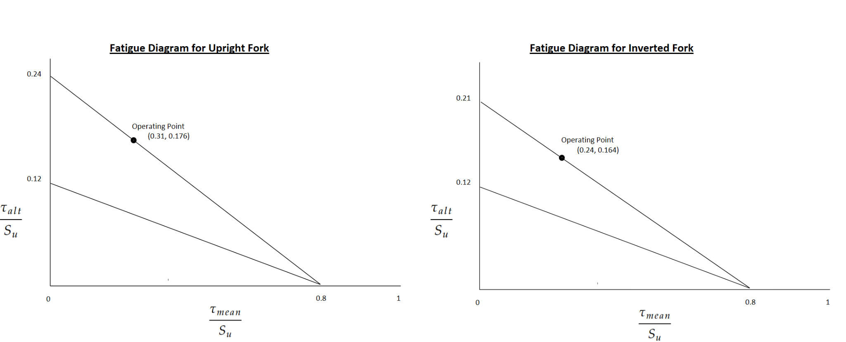

**Figure 1.** This fatigue diagram shows that the operating point and mean stresses are lower for the inverted fork, while having the same original y-intercept. As a result, the line intercepting the operating point creates a lower multiplication factor to find the true alternating stress.

It is clear that since the operating point for the inverted diagram is lower, it should lead to a greater number of cycles. By multiplying the y-intercept with the ultimate tensile strength, the cycles can be obtained using an S-N diagram:

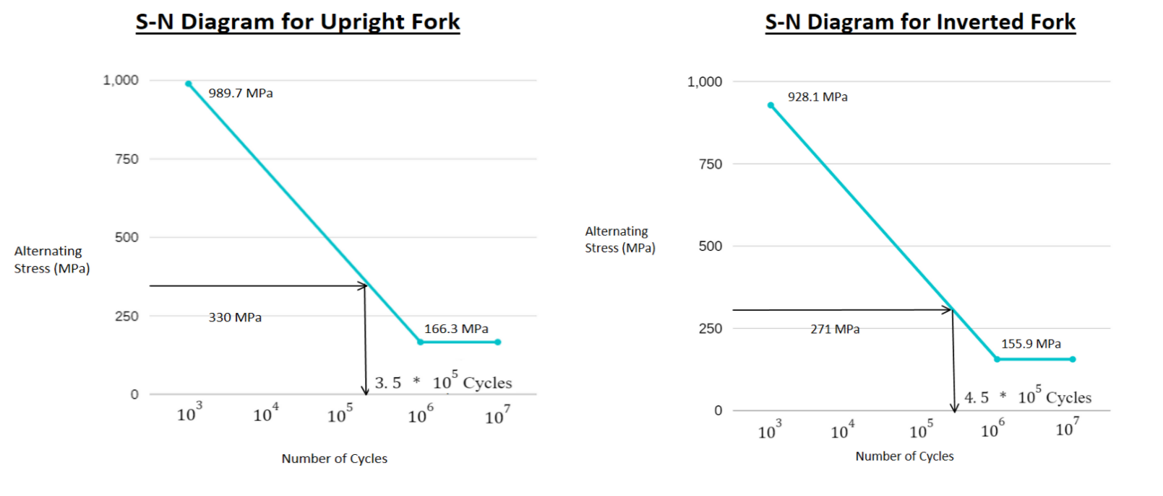

**Figure 2.** The S-N diagram’s show that the inverted fork has a lower alternating stress, and therefore generates a higher number of cycles when the stress intercepts with the S-N line.

A standard fork spring can last around 350,000 cycles at a maximum deflection of 100mm. In comparison, an inverted standard fork spring lasts 450,000 cycles at a maximum deflection of 80mm.

From the figures above and as expected, inverted fork springs have about a 22% greater lifetime than the standard fork spring at their respective deflections. However, in the real world both fork springs will last much longer than their theoretical values, as a motorcycle will never be at its maximum deflection value at all times. The findings are summarized as below:

Table 2: Stresses and Lifetime of Standard and Inverted Fork Springs

| **Mechanical Parameter** | **Standard Fork** | **Inverted Fork** |
| --- | --- | --- |
| Mean Stress (MPa) | 424.75 | 306.08 |
| Operating Point (MPa) | 241.3 | 211.12 |
| Cycles @ Maximum Deflection | 350,000 | 450,000 |

**Theoretical fork comparison**

From the above analysis, it has been made clear that an inverted fork spring provides a longer life cycle than a standard upright fork. As the spring is one of the most significant parts in the fork design, it may suggest that an inverted fork is the superior design. However, in actuality, the differences between assembly and repairability affect how feasible each design is for a given application. The traditional upright fork design is the original system used for providing dampening in a motorcycle. Its construction is very simple due to the lack of machining necessary, making it cost-effective and resulting in it making up the majority of forks on motorcycles. This is contrasted by the design of the inverted fork. Being a newer invention, the inverted fork comprises of much more complex parts and construction. Multiple comparisons can be drawn between the actual construction of the two styles of forks. Using figure BLANK as reference, the two styles of forks will be discussed in terms of physical analysis. Things such as construction, forces applied, and overall repairability will be of consideration for this comparison.

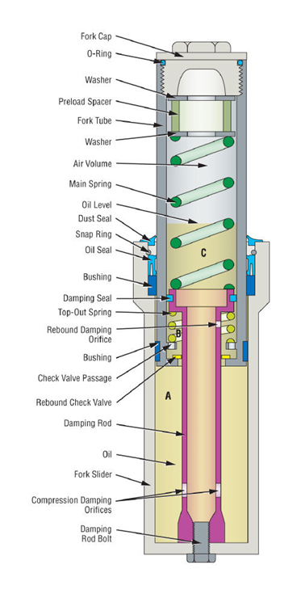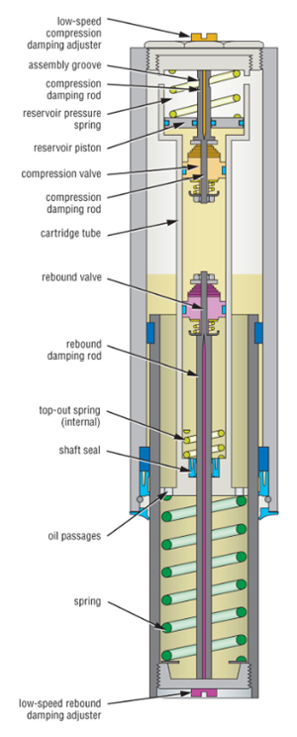

Figure BLANK: lhs standard fork. Rhs inverted fork

Other than the differences discussed in the life cycle analysis, both styles of fork mainly vary in terms of key component placement. The biggest difference is within the position of the spring within each system. The standard fork has the main dampening spring placed towards the steering rack, whereas the inverted fork has the spring placed near the wheels. The placement of the spring is vital to the unsprung mass within the system. This refers to the amount of weight remaining below the spring within a completed assembly. As the unsprung mass is closer to the ground than the parts above it, when dampening takes place, this mass is directly compressed into the chassis. Due to the upright fork having a higher unsprung mass, it leads to an increased strain being placed on the spring and every other component. The opposite is true for the inverted fork which has very little weight below the spring as its at the lowest position with respect to the fork assembly. This improves the ability of the wheels to stop and accelerate as the total weight that the fork assembly has to dampen is drastically reduced.

Although the inverted fork seems far superior in terms of lifetime and now actual performance, the level of complexity hinders this system in many ways. Its utilization of the upside-down design makes it prone to multiple types of failures. As the telescopic portion is exposed to environmental conditions, it is not uncommon to have rocks and debris wear the actual fork tube. This results in reduced dampening and in severe cases can cause leaks and breakages due to an inner surface of the fork being exposed to harsh conditions. Failures such as oil leaks are also far worse on inverted forks as the oil is located directly above the wheels and brakes. This causes further damage to other components within the vicinity of the leakage, making it far more catastrophic. Where the inverted fork lacks in reliability, the standard fork shines. Due to its simple dampening rod and spring configuration, this setup is much easier to repair and far less prone to failure as the telescopic portion is located away from the tires and any potential debris. For a regular fork the seal is also much easier to maintain due to its position on the bike whereas an inverted forks seal requires urgent care in case of a leak. For an inverted fork this seal is quite a risk with a possibility of oil leaking down onto the brake system. These leaks typically occur on longer rides and under out of city conditions such as gravel roads and do not typically occur for routine city rides.

Overall, both systems have their pros and cons, but it comes down to the actual use case to determine which one is objectively better. Inverted forks would be best used in racing events due to the added stiffness and handling that comes from the wider diameter forks and lower unsprung mass. For almost all other applications such as street riding, the standard fork would work best. Its ability to provide sufficient dampening while being relatively cost effective and less prone to failure make it the clear choice for consumers looking at this specific use case.

**3. Manufacturing**

**Cost Analysis**

When comparing inverted front forks to upright front forks, it is imperative to consider the factor of cost. Based on the analysis provided above, it can be clearly seen that inverted front forks are superior in terms of performance. Due to this, it is no surprise that motorcycle models featuring inverted front forks are more expensive. The majority of older bikes are equipped with upright front forks, so for these users it is also more expensive to purchase a kit to install an inverted front fork than to buy a replacement upright front fork. For the average consumer, a question of whether or not it is worth it to purchase a more expensive inverted fork or a motorcycle featuring an inverted fork, arises.

To analyze this question, the prices for an inverted front fork conversion kit and an upright front fork replacement for the Harley Davidson FLH/FLT model can be compared. This older model is a favorite among enthusiasts. From Kraus Motor, the conversion kit costs $6,781.00 USD while replacement upright fork legs cost $938.00 USD [3], [4]. Furthermore, the Yamaha MT-07 and the Yamaha MT-09, which feature an inverted telescopic front fork and an upright front fork respectively, can be compared. Both bikes are popular among average motorcycle riders and comparable in terms of features, with the exception of a few including the difference in front fork design and a small difference in the engine. The 2022 MT-07 costs $7899 USD while the 2022 MT-09 costs $9499 USD[1],[2].

Based on the numbers presented above, two conclusions can be drawn. For motorcycle users with older bikes, it will not be worth it to replace their current upright front fork suspension system with an inverted front fork because of the large discrepancy in cost. The performance and endurance improvements at this price deviation is simply not worth it. However, when buying a motorcycle and considering two models with similar features, it might be worth it for the average consumer to purchase a more expensive bike that features an inverted front fork rather than a traditional upright fork. The marginal difference in price can be justified due to the increased steering control and potential longer life cycle.

The springs used in the fork suspension of a motorcycle are usually made up of stainless steel wire such as 302 stainless wire, which was used for the spring torsional and lifetime analysis in the design results section of this report. Table 3 below showcases various types of suspension spring material which can be used for the motorcycle as well as some basic mechanical properties of the material along with the manufacturing method which is best suitable. It is important to note that more expensive spring material, like titanium, is usually used in inverted forks. As a result, it solidifies the idea that inverted forks are generally more expensive than upright forks.

Table 3: Spring Material Comparison

| Spring Material | Advantages | Density  ( $kg/m^{3})$ | Elastic Modulus (GPa) | Yield Strength (MPa) | Suggested Manufacturing Method | Average Cost |
| --- | --- | --- | --- | --- | --- | --- |
| Grade 302 Stainless Steel | -Demonstrates good resistance to solvents and several chemicals  -High ease of fabrication when annealed | 7889 | 193 | 275 | Cold coiling: pre-tempered material pulled through rollers and then coiled around a mold. | $1.10-$2.50/kg |
| High Strength Carbon Alloy (AISI 1050 Carbon Steel) | -Better mechanical properties than low-carbon steels  - High hardness and strength while retaining ductility | 7861 | 205 | 580 | Hot winding followed by induction tempering | $2.00-$2.50/kg |
| Chrome Silicon Steel | -High tensile strength properties beyond superalloys, high resilience to impact  -Ideal for high performance race bikes | 7861 | 207 | 630 | Hot winding followed by tempering heat treatment | $1.80-$2.90/kg |
| 6150 Chrome Vanadium Alloy Steel | -Superior toughness and ductility  -Excellent fatigue resistance for larger diameter springs | 7833 | 205 | 415 | Cold or hot winding followed by powder coating post processing to increase durability | $2.20-$3.00/kg |
| Titanium | -Exotic non ferrous material used in high performance bikes  -High strength to weight ratio making it strong, lightweight and durable | 4816 | 91 | 825 | Cold winding followed by shot peening for enhanced fatigue resistance | $110/kg |

Overall, from the table it is evident that titanium is the best material for fork springs due to its lightweight, high strength, and great durability. However, the cost associated with this material may not be feasible for most motorcycle users. It is recommended that riders only pay for more expensive material if they plan on using the bikes for high performance activities, like racing. In most cases, 302 stainless steel is sufficient for an average motorcycle rider.

References

*This unnumbered Section is required only if your Reference still is not a footnote style. Any Reference citation style is acceptable so long as the reference is unambiguous.*

1. 2022 Yamaha MT-07 Hyper Naked Motorcycle . Yamaha Motorsports. (n.d.). Retrieved April 9, 2022, from https://www.yamahamotorsports.com/hyper-naked/models/mt-07
2. 2022 Yamaha MT-09 Hyper Naked Motorcycle. Yamaha Motorsports. (n.d.). Retrieved April 9, 2022, from https://www.yamahamotorsports.com/hyper-naked/models/mt-09
3. Kraus Motor Co. (n.d.). Ohlins Drop In Cartridge Kit For Early FLH/FLT Touring. Kraus Motor Co. Retrieved April 9, 2022, from https://www.krausmotorco.com/products/ohlins-drop-in-cartridge-kit-for-early-flh-flt-97-17?_pos=1&_sid=de09ca5b0&_ss=r
4. KRT Touring Inverted Front End Kit. Kraus Motor Co. (n.d.). Retrieved April 9, 2022, from https://www.krausmotorco.com/products/krt-touring-inverted-front-end-kit

[1] Reference textbook for table 10.4

[2] <https://topdogengineer.com/fatigue-analysis-of-a-fork-spring-on-a-motorcycle-part-4/>.

[3]

Ref for manufacturing:

<https://www.azom.com/article.aspx?ArticleID=8197>

<https://www.coilingtech.com/suspension-springs/>

<https://www.civillead.com/steel-price-per-kg/>

\<https://www.neelconsteel.com/titanium-products.html>